**Adobe Illustrator Design Board**

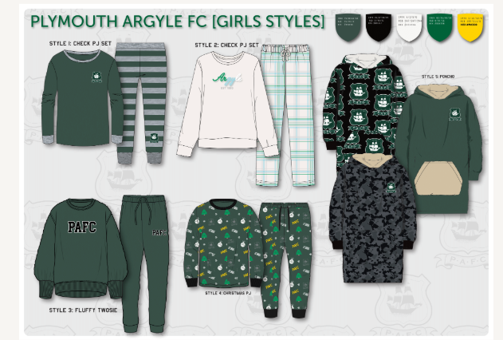

1

3

2

5

6

7

9

8

4

**Club Flies**

These will be folders that have in it an excel file with clubs criteria and logos. This will be the same and standard template for every club.

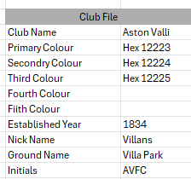

Logo 1

**Design Board Instruction**

This will be the instructions for the script to know what components need to be changed to. It will look something like below..

The numbers relate to the numbers labelled above on the Design Board.

Example of how the Design Board and Club Files link together

Logo 1

AS above the you can see how the numbers on the Design Board instructions sheet knows what information to use on Club File to make the correct changes.

Again each club file will be same template, just different information in the 2nd column.

**Howi it will be used.**

We will create multiple Design Board on a regular basis.

We will then have 2 data bases.

1. Design Boards.
2. Club Files

We can then either:

1. Choose “Design Board” and select Club Files to be created for that Design Board

Or

1. Choose a “Club File” and select the Design Boards to be created for that club file.

Question

1, Would you need to set up the script for every design board? Or would there be able to add the numbers that relate to the changes?